Max Shi  
CH 362  
Professor Attygalle  
I pledge my honor that I have abided by the Stevens Honor System.

**1) Title of experiment:**Determination of Weight Percentage of Copper in US Standard Penny With Atomic Absorption Spectrometry Using Ordinary Linear Calibration and Standard Addition Methods

Date: September 26, 2020  
Name of Technique: Atomic Absorption Spectrometry

**2) Technique:**

Atomic absorption spectrometry (AAS) is used to determine the concentration of a substance in either solid, liquid, or gaseous form, although most commonly used with solutions. The setup for this technique begins with a light source, usually a hollow cathode lamp, emitting monochromatic light associated with the element of unknown concentration. This light is shone into a high temperature flame such as air-acetylene, where the sample solution is aspirated. Along the same path, the light going through the flame is directed into a monochromator, which cuts off radiation of all other wavelengths besides the one associated with the unknown element. Finally, a photodetector is set up at the end of the line to read the final transmittance.

The concept behind this technique is that when a solution is atomized, certain elements in the solution, such as metals, will transition to free ions in the gaseous state, and absorb light in particular wavelengths. The higher the concentration of the ions in the original solution, the more light will be absorbed, the transmittance will lower, and the absorbance will increase. Measuring the transmittance of known solutions with the photoreceptor will allow determination of the concentration of an unknown solution through interpolation of an absorbance plot.

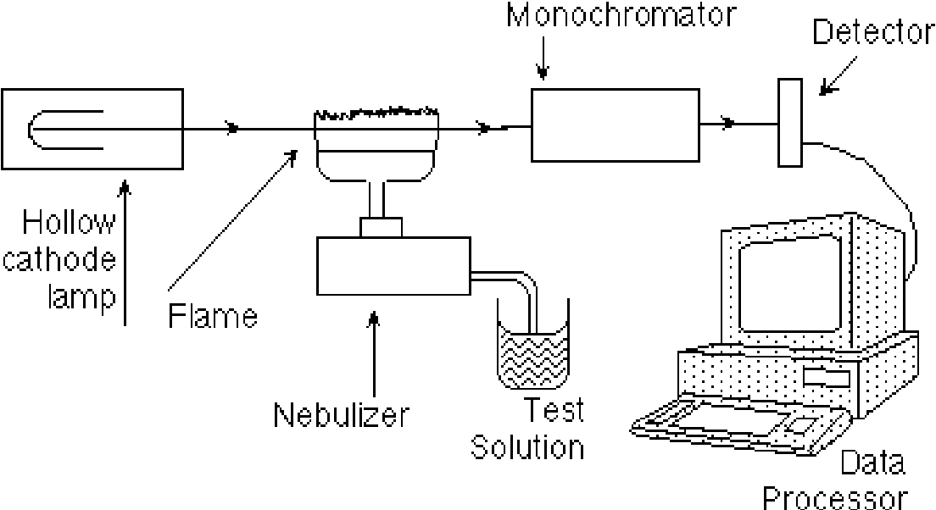

Figure 1: Atomic Absorption Spectrometry Setup

**3) Application of the Technique to my Experiment:**

In this experiment, we are attempting to use two variations of this technique to determine the percentage of copper in a standard US penny. To apply this technique, a US copper penny must be completely dissolved in solution to be aspirated into the flame. To accomplish this, the copper penny will be placed in a solution of HCl and HNO3, converting the copper to its ion, Cu2+, according to equation 1.

$$Cu\left(s\right) + 4{HNO}_{3}\left(aq\right) → Cu{\left({NO}_{3}\right)}_{2}(aq) + 2{NO}_{2}(g) + 2H_{2}O(l)$$

Equation 1: Reaction of Copper to its Ion with Nitric Acid

Determining the concentration of the copper ion of the resulting solution will allow us to recover the weight percentage of copper in the penny. In this experiment, this will be done with two methods.

The first method is using Ordinary Linear Calibration with standard solutions of known concentration. In this experiment, Cu(NO3)2•3H2O will be dissolved to create a solution of known concentration, called the stock solution, which will then be split into six solutions of different concentrations, called calibration solutions. Each of these calibration solutions will be aspirated and the transmittance will be measured in order to create a linear absorbance plot. Then, the solution with the copper from the penny will be diluted and aspirated into the AAS apparatus to determine a transmittance value, which can be interpolated to a concentration with the plot. As an aside in this experiment, the copper concentration in tap water and deionized water will also be determined with the same method.

The second method, Standard Addition, is based on adding known quantities of analyte to an unknown solution to determine the concentration of the original unknown solution through measuring the change in absorbance. In this method, a small amount of the original penny solution will be transferred into four flasks. Then, different amounts of the stock solution will be added to each flask, (except one, which will be marked 0ppm) and each flask will be diluted to form solutions of different “concentrations.” Although these flasks are marked based on the amount of stock solution added, the true concentration would include the copper ions added by the original unknown solution. Then, each solution will be aspirated and plotted on an absorbance plot. In this case, the beaker marked 0ppm will not have an absorbance of 0, and by extrapolating the line, the concentration of the unknown solution can be determined.

**4) Calculations:**

**Preparation of 100 mL of 100ppm Cu2+ solution**

|  |  |
| --- | --- |
| Desired volume | 100 mL |
| Weight of Cu2+ needed | 100 ppm = 100 mg/L * 0.1 L = 10 mg |
| Molar mass of Cu | 63.546 g/mol |
| Molar mass of Cu(NO3)2•3H2O | 241.60 g/mol |
| Weight percentage of Cu in Cu(NO3)2•3H2O | 63.546 / 241.60 = 26.3% |
| Mass of Cu(NO3)2•3H2O needed | 10 mg / 26.3% = 0.038 g |

**Preparation of six 100.00 mL standard calibration solutions**

To prepare a solution of x ppm from a solution of 100 ppm with the same volume:

100 mL solution of 100 ppm contains 100 mg/L, implies 1 mg/mL solution.  
100 mL solution of x ppm requires x mg of solute.  
Thus, to prepare a 100 mL solution of x ppm, add x mL of stock solution and dilute to 100 mL.

|  |  |  |  |
| --- | --- | --- | --- |
| **Solution Number** | **Concentration of Cu2+** | **Volume of stock solution (mL)** | **Volume of water (mL)** |
| **1** | 1 ppm | 1 | 99 |
| **2** | 2 ppm | 2 | 98 |
| **3** | 3 ppm | 3 | 97 |
| **4** | 5 ppm | 5 | 95 |
| **5** | 8 ppm | 8 | 92 |
| **6** | 10 ppm | 10 | 90 |

**5) References:**

1. 3-Figure2-1.png (PNG Image, 1104 x 602 pixels)  
   <https://www.semanticscholar.org/paper/Photochemical-Studies-of-Solanum-Melangena-Fruit-by-Persid-Verma/05061e90a235d14e9ea46e2c6f07a4af0e76b6f3/figure/3> (accessed Sep 26, 2020)
2. Demonstrations - Copper + Nitric Acid <https://www.angelo.edu/faculty/kboudrea/demos/copper_HNO3/Cu_HNO3.htm> (accessed Sep 26, 2020).
3. Harris, D. C. *Quantitative Chemical Analysis*, 8th ed.; W.H. Freeman and Co: New York, 2010. Chapter 10, 15.
4. Hardness of Water <https://www.usgs.gov/special-topic/water-science-school/science/hardness-water?qt-science_center_objects=0#qt-science_center_objects> (accessed Sep 26, 2020).
5. Influence of Burner Head Geometry on Flame Characteristics in AAS Analysis. <https://lab-training.com/2014/04/23/influence-of-burner-head-geometry-on-flame-characteristics-in-aas-analysis/> (accessed Sep 26, 2020)
6. (1)

**6) MSDS:**

**Acetylene:**

CAS No.: 74-86-2  
Molecular Weight: 26.04  
Chemical Formula: C2H2  
Appearance: colorless gas  
Lab Protective Equipment: Lab coat, goggles, gloves  
Flammable gas.

**Health effects:**Vapors can cause drowsiness and dizziness, and irritation to respiratory system. High concentrations can displace air, causing lack of oxygen. High vapor concentrations can cause central nervous system depression. Exposure to rapidly expanding gas can cause frost burns to eyes or skin.

**First Aid measures:**Eye contact: Slowly warm exposed area by rinsing with warm water. Transport to nearest medical facility.  
Skin contact: Slowly warm exposed area by rinsing with warm water. Transport to nearest medical facility.  
Inhalation: Move to fresh air. If victim is having trouble breathing, give 100% oxygen. If not breathing, give 100% oxygen through artificial respiration. Transport to nearest medical facility.  
Ingestion: Obtain medical attention immediately.

**Other hazards:**Fire: Flammable gas.  
Explosion: Vapors may cause explosion.

**Nitric Acid:**

CAS No.: 7697-37-2  
Molecular Weight: 63.01  
Chemical Formula: HNO3  
Appearance: colorless liquid  
Lab Protective Equipment: Lab coat, goggles, gloves  
Strong oxidizer, corrosive to metals.

**Health effects:**Can cause skin corrosion, serious eye damage, and is toxic when inhaled. May cause liver damage.

**First Aid measures:**Eye contact: rinse thoroughly with plenty of water for 15 minutes and consult physician. Continue rinsing eyes during transport to hospital.  
Skin contact: take off contaminated clothing and shoes immediately. Wash area with plenty of soap and water. Take victim immediately to hospital. Consult a physician.  
Inhalation: Move to fresh air. If not breathing, give artificial respiration. Consult a physician.  
Ingestion: Do NOT induce vomiting. Never give anything by mouth to an unconscious person. Rinse mouth with water and consult a physician.

**Other hazards:**Fire: may intensify fire. Hazardous products formed under fire conditions.  
Explosion: Not considered to be an explosive hazard.

**Hydrochloric Acid:**

CAS No.: 7647-01-0  
Molecular Weight: 36.46  
Chemical Formula: HCl  
Appearance: light yellow liquid  
Lab Protective Equipment: Lab coat, goggles, gloves  
Oxidizer, may be corrosive to metals.

**Health effects:**Causes severe skin burns and eye damage. May cause respiratory irritation, toxic to respiratory system.

**First Aid measures:**Eye contact: rinse thoroughly with plenty of water for 15 minutes and consult physician. Continue rinsing eyes during transport to hospital.  
Skin contact: take off contaminated clothing and shoes immediately. Wash area with plenty of soap and water. Consult a physician.  
Inhalation: Move to fresh air. If not breathing, give artificial respiration. Consult a physician.  
Ingestion: Do NOT induce vomiting. Never give anything by mouth to an unconscious person. Rinse mouth with water and consult a physician.

**Other hazards:**Fire: may intensify fire. Hazardous products formed under fire conditions.  
Explosion: Not considered to be an explosive hazard.

**Copper Nitrate Trihydrate:**

CAS No.: 10031-43-3  
Molecular Weight: 241.60  
Chemical Formula: Cu(NO3)2•3H2O  
Appearance: blue crystals  
Lab Protective Equipment: Lab coat, goggles, gloves  
Strong oxidizer, contact with other material may cause fire.

**Health effects:**Causes skin and eye irritation. May be harmful if absorbed through skin. Harmful if swallowed, may cause irritation of digestive tract. May cause respiratory tract irritation. Exposure to high concentrations may cause central nervous system depression, cancer.

**First Aid measures:**Eye contact: Immediately flush eyes with plenty of water for at least 15 minutes, occasionally lifting the upper and lower eyelids. Get medical aid.  
Skin contact: take off contaminated clothing and shoes immediately. Wash area with plenty of soap and water. Get medical aid.  
Inhalation: Move to fresh air. If breathing is difficult, give oxygen. If not breathing, give artificial respiration through a one-way valve or other respiratory device. Get medical aid.  
Ingestion: Do NOT induce vomiting. Get medical aid immediately. Contact a poison control center.

**Other hazards:**Fire: Exposure to some combustible materials may cause fire.  
Explosion: Not considered to be an explosive hazard.

**Copper:**

CAS No.: 7440-50-8  
Molecular Weight: 63.54  
Chemical Formula: Cu  
Appearance: Light red solid  
Lab Protective Equipment: Lab coat, goggles, gloves

**Health effects:**No serious health effects.

**First Aid measures:**Eye contact: Flush eyes with water as a precaution.  
Skin contact: Wash with soap and plenty of water. Consult a physician.  
Inhalation: Move to fresh air. If not breathing, give artificial respiration. Consult a physician.  
Ingestion: Never give anything by mouth to an unconscious person. Rinse mouth with water and consult a physician.

**Other hazards:**Fire: not known to be a fire hazard.  
Explosion: not known to be an explosion hazard.

**7) Pre-lab questions:**

1. Solid samples can be analyzed by AAS by either dissolving the solid into solution if it readily dissolves, reacting a solid with an acid to create an ion in solution, such as we do in this experiment. Then, the solution is nebulized and aspirated into the flame to perform AAS. Another way to analyze solid sample is to use direct solid sampling in a furnace, which can atomize impurities in solids, allowing concentrations of these impurities in solid substances to be measured depending on the melting point of different metals in the solid.
2. A monochromator is an apparatus with mirrors that disperses light into component wavelengths through its entrance slit, where a small range of wavelengths can be selected to be passed on to another device through the exit slit. In this way, monochromators can filter out undesired wavelengths of light coming through the entrance slit, such as light absorbed by burning other impurities in the aspirated solution during AAS.
3. The formula of acetylene is C2H2. Acetylene is an odorless, colorless gas, with a density of 1.097 g/L, making it slightly less dense than air. It has a molar mass of 26.04 g/mol, and no melting point at atmospheric pressure, but a sublimation point of 84°C. It is very flammable, and autoignites at 300°C.
$2 C{}_{2}H_{2}\left(g\right)+{5 O}_{2}\left(g\right)→4 CO_{2}(g)+{2 H}_{2}O(l)$

4. Because only a small amount of solution gets aspirated into the flame at a time, a long slot flame burner allows for more aerosol to burn in the flame as the light passes through the flame. Longer path length, therefore, maximizes the absorption signal strength and makes the readings more consistent.
5. Hard water is water with high mineral content, in the form of dissolved calcium and magnesium ions in the water. These minerals get into water as it flows through the earth as groundwater, collecting magnesium and calcium from the soil and rocks.
6. Plotting these on a graph and doing the linear regression gives the equation $$emission=23.9509*sample$$ 
   Plugging in 417 for the emission and solving for sample gives 17.41 µg K/mL